unit 3
UNIT – III BI Implementation - Key Drivers, Key Performance Indicators and Performance Metrics, BI Architecture/Framework, Best Practices, Business Decision Making, Styles of BI-vent-Driven alerts-A cyclic process of Intelligence Creation. The value of Business intelligence -Value driven and Information use.
Performance measurement systems: Assist managers in tracking the implementations of business strategy by comparing actual results against strategic goals and objectives.
A performance measurement system typically comprises systematic methods of setting business goals together with periodic feedback reports that indicate progress against goals.
All measurement is about comparisons. Raw numbers are rarely of little value. If you were told that a salesperson completed 50 percent of the deals he or she was working on within a month, that would have little meaning. Now, suppose you were told that the same salesperson had a monthly close rate of 30 percent last year. Obviously, the trend is good. What if you were also told that the average close rate for all salespeople at the company was 80 percent? Obviously, that particular salesperson needs to pick up the pace.
In performance measurement, the key comparisons revolve around strategies, goals, and objectives.
There is a difference between a "run of the mill" metric and a "strategically aligned" metric. The term key performance indicator (KPI) is often used to denote the latter
A KPI represents a strategic objective and measures performance against a goal.this means that KPis have a variety of distinguishing features, including:
•Strategy. KPis embody a strategic objective.
•Targets. KPis measure performance against specific targets. Targets are defined in strategy, planning, or budget sessions and can take different forms (e.g., achievement targets, reduction targets, absolute targets).
•Ranges. Targets have performance ranges (e.g., above, on, or below target).
•Encodings. Ranges are encoded in software, enabling the visual display of performance (e .g., green, yellow, red). Encodings can be based on percentages or more complex rules.
• Time frames. Targets are assigned time frames by which they must be accomplished. A time frame is often divided into smaller inte1vals to provide performance mileposts.
• Benchmarks. Targets are measured against a baseline or benchmark. The previous year's results often serve as a benchmark, but arbitra1y numbers or external benchmarks may also be used.

Key Drivers
A distinction is sometimes made between KPis that are "outcomes" and those that are "drivers." Outcome KPis-sometimes known as lagging indicators-measure the output of past activity (e.g., revenues). They are often financial in nature, but not always.
Drivers known as leading indicators or value drives-measure activities that have a significant impact on outcome (e.g., sales leads).
In some circles, driver KPis are sometimes called operational KPis, Most organizations collect a wide range of operational metrics. As the name implies, these metrics deal with the operational activities and performance of a company.
The following list of examples illustrates the variety of operational areas covered by these metrics:
• Customer performance. Metrics for customer satisfaction, speed and accuracy of issue resolution, and customer retention.
•Service performance. Metrics for service-call resolution rates, se1vice renewal rates, service level agreements, delivery performance, and return rates.
• Sales operations. New pipeline accounts, sales meetings secured, conversion of inquiries to leads, and average call closure time.
•Sales planforecast. Metrics for price-to-purchase accuracy, purchase order.
For example, in sales analysis, key drivers could be factors such as marketing campaigns, pricing strategies, customer demographics, or product features. By analyzing these key drivers, organizations can determine which factors have the most significant impact on sales performance and prioritize their resources and efforts accordingly.
Effective Performance Measurement
• Measures should focus on key factors.
• Measures should be a mix of past, present, and future .
• Measures should balance the needs of shareholders, employees, partners, suppliers, and other stakeholders.
• Measures should start at the top and flow down to the bottom.
• Measures need to have targets that are based on research and reality rather than be arbitia1y.
Performance Metrics and Key Performance Indicators
Performance Metrics, on the other hand, are more granular and focused measurements that track specific aspects of performance within an organization. These metrics can be quantitative or qualitative and provide more detailed insights into operational areas and processes.
Performance metrics measure how well we perform within a particular business context.
A performance metric relates an objective ‘‘score’’ (with a specific unit of measures) within a subjective scale of success.
As an example, we might have a measure of the number of calls handled by each call center representative per hour. The unit of measure is the ‘‘number of calls,’’ but this measure provides only an objective score, but does not provide any subjective insight. Assessing comparative performance means determining the expected number of calls to be handled per hour, as well as specific target goals. To continue the example, the expected number of calls to be handled is 10, while the target could be set at 15.
KPIs are specific, measurable values that reflect the performance of an organization in achieving its strategic goals and objectives.
KPIs are critical metrics used to monitor and evaluate performance and track progress towards specific goals.
The higher-level metrics that describe a broader view of corporate success. The highest level of metric is the key performance indicator (KPI), which is some objective measurement of an aspect of a business that is critical to the success of that business.
From a functional standpoint, key performance indicators encompass a wide variety of financial, marketing, sales, customer service, manufacturing and supply chain metrics. KPIs can also be used to track performance metrics related to internal processes, such as human resources and IT operations.
In the context of BI, KPIs and Performance Metrics are used to assess and monitor performance using data-driven insights. BI tools and systems collect, analyze, and present data related to these indicators, allowing stakeholders to track progress, identify trends, and make informed decisions.
For example, a KPI in BI for a retail business could be the average revenue per customer, which reflects the overall financial performance and customer value. Supporting Performance Metrics could include metrics like average transaction value, average units sold per transaction, or customer retention rate, which provide more detailed information about specific aspects of revenue generation and customer behavior.
KPIs can be collected together to provide a conceptual scorecard for a business and can be associated with a number of different business activities, especially within our four value driver areas such as financial value, productivity, risk, and trust. In fact a large number of KPIs can be defined in terms of measuring performance associated with many different BI analytical activities.
Another conceptual value of BI is the ability to capture the business definitions of the key performance indicators, manage those definitions as part of the corporate knowledge base, and then provide a visualization dashboard that reflects those KPI measurements, presented in a form for management review.
This BI dashboard displays the results of the analytics required to configure the KPIs in a succinct visual representation that can be understood instantaneously or selected for drill-down. A BI dashboard will not only provide real-time presentation of the selected KPIs, but will also hook directly into the BI components that allow for that drill-down.
BI framework goes beyond the technology key stakeholders must specify what their perception of ‘‘performance’’ is, provide the performance measures, and then define achievable targets and use the tools to inform the decision-making processes.
These measures are put in place to assess, measure, and control the degree to which the business objectives are being met.
Specific programs can be designed and developed around improvements within any of these key categories.
Consider these examples:
Revenue generation via customer profiling and targeted marketing. Business intelligence reports and analyses reflecting customer transactions and other interactions enable the development of individual customer profiles incorporating demographic, psychographic, and behavioral data about each individual to support customer community segmentation into a variety of clusters based on different attributes and corresponding values. These categories form the basis of sales and profitability measures by customer category, helping to increase sales efforts and customer satisfaction.
Risk management via identification of fraud, abuse, and leakage. Fraud, which includes intentional acts of deception with knowledge that the action or representation could result in an inappropriate gain, is often perpetrated through the The Value of Business Intelligence 19 exploitation of systemic scenarios. Fraud detection is a type of analysis that looks for prevalent types of patterns that appear with some degree of frequency within certain identified scenarios. Reporting of the ways that delivered products and services match what had been sold to customers (within the contexts of their contracts/agreements) may highlight areas of revenue leakage. Both of these risks can be analyzed and brought to the attention of the proper internal authorities for remediation.
Improved customer satisfaction via profiling, personalization, and customer lifetime value analysis. Customer lifetime value analysis calculates the measure of a customer’s profitability over the lifetime of the relationship, incorporating the costs associated with managing that relationship as well as the revenues expected from that customer. Employing the results of customer profiling can do more than just enhance that customer’s experience by customizing the presentation of material or content. Customer profiles can be directly integrated into all customer interactions, especially at inbound call centers, where customer profiles can improve a customer service representative’s ability to deal with the customer, expedite problem resolution, and perhaps even increase product and service sales.
Improved procurement and acquisition productivity through spend analysis. Spend analysis incorporates the collection, standardization, and categorization of product purchase and supplier data to select the most dependable vendors, streamline the RFP and procurement process, reduce costs, improve the predictability of high-value supply chains, and improve supply-chain predictability and efficiency. Each of these examples can be viewed in both the operational and the strategic business perspectives. The operational view provides insight into existing conditions and performance comparing existing activities to expectations. From the strategic perspective, we can evaluate the degree to which any potential measurements impact future corporate value.
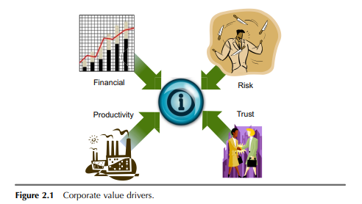

How do organizations use key performance indicators?
KPIs differ from organization to organization depending on the business priorities. For example, one of the key performance indicators for a public company might be its stock price, while a KPI for a privately held startup company might be the number of new customers added each quarter. Even direct competitors in an industry are likely to monitor different sets of KPIs tailored to their individual business strategies and management philosophies.
The KPIs different people in the same organization closely follow can also vary depending on their roles. For example, a CEO might consider profitability to be the best KPI for the company, while the vice president of sales might consider the ratio of a sales team’s wins vs. losses as the highest-priority KPI.
Different business units and departments are also typically measured against their own KPIs, resulting in a mix of performance indicators throughout an organization -- some at the corporate level and others geared toward specific operations.

Importance of key performance indicators
KPIs are critical to the health and profitability of an organization for the following reasons:
- Key performance indicators focus on how well a business is doing. Without KPIs, it would be difficult for an organization’s leaders to evaluate that in a meaningful way and then make operational changes to address performance issues.
- Keeping employees focused on business initiatives and tasks that are central to organizational success would be challenging without designated KPIs to reinforce the importance and value of those activities.
- In addition to highlighting business successes or issues based on measurements of current and historical performance, KPIs can point to future outcomes, giving executives early warnings of possible business problems or advance guidance on opportunities to maximize return on investment. Armed with such information, leaders can manage business operations more proactively, with the potential to gain competitive advantages over rivals.

Types of key performance indicators
The following are the four most common types of KPIs:
- Lagging indicators. KPIs that measure the results of business activities, such as quarterly profit and revenue growth, are referred to as lagging KPIs because they track things that have already occurred.
- Leading indicators. By comparison, leading KPIs are those that herald upcoming business developments -- for example, sales bookings that generate revenue in future quarters.
- Quantitative indicators. Indicators such as revenue or website traffic can be measured numerically. They’re easy to assess and compare over time and are frequently used to monitor progress toward specified numerical targets. Quantitative indicators provide accurate, data-based insight into how well a company or organization is performing.
- Qualitative indicators. Qualitative indicators are more abstract and open to interpretation, such as user experience with a product or on a website. In the case of qualitative indicators, identifying useful KPIs can be challenging; selecting appropriate ones depends on an organization’s ability to measure KPIs in some way. For example, the percentage of abandoned transactions in online shopping carts might be one indicator of customer satisfaction and customer retention on a retail website.

Developing key performance indicators
The process of creating the right KPIs involves several steps, but most organizations typically use the following approach:
- Establish strategic goals. Determine the organization’s or department’s primary strategic objectives before generating KPIs for it. Describe the expected outcomes that help achieve those business goals. For example, before creating the KPIs, the organization must specify the precise results it’s striving for.
- Recognize alternate performance measures. Try to find alternate performance metrics that could be used to attain the desired outcomes. For example, the company should ask what additional metrics might be used to evaluate development.
- Select the best-suited KPIs. Decide which KPIs are most appropriate for achieving each desired outcome. Once identified, these metrics should be used because they demonstrate progress toward the desired goal.
- Define and record the KPIs. Define and record the chosen KPIs, including their calculation process, data sources, frequency of collection and any benchmarks or targets that might be required.
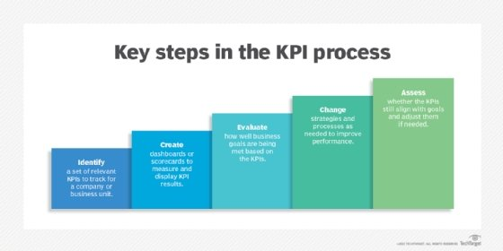Organizations can use these steps to create KPIs to highlight business successes or to identify areas of the business that need to be managed more proactively.

How to improve an existing KPI strategy
If the key performance indicators don’t deliver the expected outcomes, it’s time to adjust the KPI strategy. Organizations can take the following actions to make sure KPIs are used effectively:
- Choose the most crucial KPIs. A balance of leading and lagging indicators should be used to ensure that the most important elements are being measured. Lagging indicators make it easier to comprehend results over time, such as sales over the past 30 days, while using data-based predictions. Leading indicators enable organizations to make changes to their strategy to achieve better and attainable results.
- Establish a KPI-driven culture. KPIs are useless if people don’t know what they indicate and how to use them. To ensure that everyone is working toward strategic goals, data literacy should be increased across the organization. Companies should employ best-in-class business intelligence software, train workers and provide them with relevant KPIs to guarantee decision-making that benefits the business.
- Iterate. It’s important to stay up to date with key performance indicators by updating them in response to market, customer and organizational changes. Companies should regularly review KPIs, carefully assess performance to identify any improvements that are required and disclose any modifications they make so that teams are constantly up to speed.
- Evaluate the data sources. Review the data sources and data gathering techniques used for creating the current KPIs. Organizations must evaluate if there are any changes they can make to ensure accurate and timely data collection.
- Contact key organizational stakeholders for feedback. To learn more about KPI metrics and any potential areas for improvement, key stakeholders within the organization should be asked for feedback.

How to measure key performance indicators
Once an organization identifies good KPIs, they should be clearly communicated to employees so all levels of the organization understand which business metrics matter the most and what constitutes successful performance against them. This could include the entire workforce for broad corporate KPIs or smaller groups of workers for KPIs that apply to particular departments.
The following are some best practices for measuring key performance indicators:
- Identify tools for measuring KPIs. In most companies, KPIs are automatically tracked by business analytics and reporting tools that collect relevant data from operational systems and create KPI reports on the measured performance levels.
- Present data visualizations through dashboards. Increasingly, KPI results are presented to executives on business intelligence dashboards or performance scorecards that often include charts and other data visualizations, with the ability to drill down into the performance data for further analysis.
- Provide a broader view of performance. Multiple KPIs also underlie balanced scorecard frameworks that pull together sets of metrics to provide a broader view of business performance beyond operating income and other common financial measurements.
- Create standard and customized reports. Using KPI software with both standard and customized reporting can be beneficial. While certain KPIs are useful on their own, others might require accompanying metrics to clarify the meaning of the data. For example, if the KPI is a social media engagement, the organization could also include details about each social media site that its team uses.
- Limit the scope of KPIs to track. One of the challenges in setting key performance indicators is deciding how many to track to determine organizational success. Having too many KPIs can dilute the attention paid to the truly important ones. As a result, it could be more effective to limit the scope to small sets of indicators.
- Continually evaluate KPIs. Managers must constantly evaluate KPIs to ensure they’re still relevant and aligned with priorities in business operations. If individual KPIs no longer serve a useful purpose, they should be refined or replaced.

Examples of key performance indicators
A company’s business strategy and the sector in which it operates influences the KPIs it chooses. In contrast to brick-and-mortar retailers, business-to-business software-as-a-service companies might opt to concentrate on customer acquisition and churn rather than revenue per square foot or average customer spend.
The following are some examples of industry-standard KPIs.

Financial KPIs
Beyond revenue, expenses and profit, commonly used financial KPIs include the following:
- Gross and net profit margin, which measure how much money a company makes on sales of products.
- Inventory turnover, which tracks how quickly products held in inventory are sold.
- Cost of goods sold, a measure of the materials and labor costs incurred in making products.
- Accounts receivable turnover, a ratio that quantifies how quickly payments on credit sales are collected from customers.
- Days sales outstanding, a related metric that gauges the number of days’ worth of receivables that have yet to be collected.
Thanks to artificial intelligence and machine learning, many finance teams and CFOs are now adopting financial business analytics tools more frequently to increase their success with KPIs.

Marketing and sales KPIs
These include the following:
- Lead conversion rate, which measures the percentage of sales leads that are successfully turned into customers.
- Customer acquisition cost, which calculates the average cost of acquiring new customers in marketing and sales expenses.
- Return on marketing investment, which quantifies the financial payback of marketing campaigns and programs.
- Customer lifetime value, which predicts the total profit a company is likely to make from sales to individual customers.
- Customer churn rate, which measures how many customers stop buying a company’s products.

Customer service KPIs
Key performance indicators in customer service call centers include the following:
- First call resolution rate, which tracks the percentage of incoming inquiries from customers that are addressed without the need for additional calls.
- Cost per call, which quantifies the average cost of handling calls.
- Call volume, which measures the total number of calls handled during a particular period.
- Hold time, which measures the average time customers spend on hold during calls.
- Abandoned calls, a ratio expressing the number of calls terminated by customers on hold vs. the total number of calls.
Additionally, longer-term, preventative KPIs such as employee engagement and knowledge base articles are sometimes included in customer service KPIs.

Manufacturing KPIs
KPIs for manufacturing and supply chain operations include the following:
- The percentage of defective products made by a company.
- Manufacturing cycle time, which measures how long it takes to make products.
- Carrying cost, which puts a value on what it costs to keep products in inventory.
- Percentage of out-of-stock items, which tracks the number of products that aren’t available in inventory when customers order them.
- Back-order rate, which is a related metric that quantifies the number of orders that can’t be filled when they’re placed.
- Return rate, which assesses the percentage of items a customer returns.

Human resources KPIs
Compensation, labor management and recruitment are the three main concerns of HR departments. As such, they often track the following key performance indicators:
- Employee satisfaction levels.
- Turnover rates.
- Absenteeism rate.
- Quality of hire.
- Promotion rate.
- Vacancy rates.

IT KPIs
IT managers commonly look at the following KPIs, among others:
- System uptime.
- Compliance with service-level agreements.
- Total support tickets.
- Critical bugs.
- Server downtime.
- On-time project completion rates.
- Average resolution time on help desk tickets.
Industry-specific KPIs have also been created in retail, healthcare, financial services and other markets. For example, a retailer might track things such as the average purchase value of sales transactions and sales per square foot of brick-and-mortar retail space, while a healthcare organization might measure emergency room wait times, the average length of stay in a hospital and patient readmission rates.

Business Intelligence Best Practices
Business Buy-in, Collaboration, and Ownership
Aim for complete buy-in from the executive board and take the help of technology heads to explain the benefits and processes. Form an internal network of contributors to enrich the data environment continuously. This network should consist of personnel from every team including Marketing, Sales, Logistics, Finance, Delivery, Management, and Customer Service. The business units must not depend on IT to generate reports and insight.
BI Implementation Strategy
A couple of years ago, a Forbes article by a fintech leader predicted that more than 150 zettabytes of real-time data will need analysis by 2025. The complete potential of data is yet to be discovered. We are dealing with massive loads of data and without a practical Business Intelligence implementation strategy, your ROI might not live up to the TCO (Total Cost of Ownership).
Monitor, Learn and Adjust the process
Unless you have a seasoned team of Data Scientists, you will most likely find some roadblocks at the initial phase of your Data Management and Business Intelligence creation. Don’t let a few hiccups dull your motive, rather take the IT team's help to establish continuous monitoring systems, access your data sources, understand the underlying conditions, and adjust the elements to align your BI strategy to your business goals.
Data Validation for Certainty and Accuracy
A ‘Vote in’ doesn’t directly imply trust over the process. A few business units, their leaders, or some of the key contributors may have a lot of questions about how accurate are the insights that are being produced from the so-called Business Intelligence practices. Organizations need strong Data Validation processes in place to gain true trust from every business user. Design the validation process to be able to detect and prevent problematic data, avert faulty insights, and add agility.
Business Challenge comes first and then the Query
Just because you’ve built a data repository don’t expect the business users to dive right in with queries. Business Intelligence sure is a magic wand that can bring you insight with few clicks but step one is always dissecting the business challenge. First, have a clear list of metrics you want to track and analyze, and then place your query for Insights.
Design your Business Intelligence dashboard informative and impactful
The BI dashboard is one of the most important aspects of your BI reporting. Data Visualization is not only for aesthetic purposes, but also to add simplicity, readability, clarity, and let the users effortlessly find the information. Opt for a dashboard design that presents detailed analysis as needed in a downward flow. Modern Data Architectures emphasize regulations and access control. Take advantage of the access information to display the relevant KPIs and Metrics at the top of each log-in.
Upskill the business users
The scarcity of top-notch data scientists is real. But you can turn the most inquisitive employees of your workforce into information analysts. Because they already know the business domain, understand their respective business units, and know what questions to ask. All they need is some training to handle the platforms and unmodeled data sets. This could be your first step towards self-service Business Intelligence.
Business decision making
Business decision making in the context of business intelligence (BI) refers to the process of using data, insights, and analytical tools to make informed and effective decisions that drive business performance and success. BI provides organizations with valuable information and analysis to support decision making at various levels, from operational to strategic.
Here's how business decision making is facilitated by business intelligence:
Data-driven insights: BI leverages data from various sources and applies analytical techniques to uncover patterns, trends, and relationships within the data. These insights provide a factual basis for decision making, reducing reliance on intuition or guesswork.
Performance monitoring: BI enables organizations to monitor key performance indicators (KPIs) and track progress towards business goals. Decision makers can access real-time or near-real-time data to assess performance, identify areas for improvement, and take appropriate actions.
Ad hoc analysis: BI tools provide ad hoc querying and analysis capabilities, allowing decision makers to explore data and gain deeper insights into specific issues or questions. They can manipulate data, apply filters, and perform custom analysis to support decision making on the fly.
Scenario modeling and forecasting: BI tools often include forecasting and predictive analytics capabilities. Decision makers can create scenarios and simulate different business conditions to assess potential outcomes and make decisions based on likely future scenarios.
Collaborative decision making: BI platforms often support collaboration and data sharing among decision makers. Multiple stakeholders can access the same data, reports, and dashboards, fostering collective understanding and consensus-driven decision making.
Data visualization: BI tools offer interactive and visually appealing data visualizations, such as charts, graphs, and dashboards. These visual representations simplify complex information, making it easier for decision makers to understand trends, patterns, and relationships in the data.
Historical analysis: BI enables decision makers to analyze historical data to gain insights into past performance, trends, and factors that have influenced business outcomes. This historical context helps inform current decision making and future planning.
Agility and responsiveness: BI enables organizations to quickly respond to changing business conditions and make agile decisions. Real-time data and analytical capabilities allow decision makers to adapt strategies, adjust operations, and seize opportunities as they arise.
By leveraging business intelligence, organizations can enhance their decision-making processes by integrating data, analysis, and insights into the decision-making workflow. This data-driven approach helps organizations make more informed, strategic, and effective decisions, leading to improved business outcomes.
In addition to event-driven Business Intelligence (BI), there are other styles or approaches in BI that organizations can utilize. Here are a few examples:
Real-Time Business Intelligence: Real-time BI focuses on providing immediate access to data and insights as events occur. It involves capturing, processing, and analyzing data in real-time or near real-time, enabling organizations to make timely decisions and respond quickly to changing circumstances. Real-time BI often leverages technologies such as streaming analytics, in-memory databases, and real-time data integration.
Mobile Business Intelligence: Mobile BI involves delivering BI capabilities and insights to mobile devices such as smartphones and tablets. It enables users to access and analyze data on the go, providing flexibility and convenience. Mobile BI often utilizes responsive design, mobile apps, and optimized visualizations to provide a seamless and user-friendly experience.
Self-Service Business Intelligence: Self-service BI empowers users to independently access, analyze, and visualize data without relying on IT or data specialists. It involves providing user-friendly tools and interfaces that enable users to perform data discovery, create reports, and build visualizations with minimal technical skills. Self-service BI promotes data democratization, empowering users across the organization to derive insights and make informed decisions.
Embedded Business Intelligence: Embedded BI integrates BI capabilities directly into existing applications or systems. It enables users to access relevant data and insights within their workflows, eliminating the need to switch between different tools or interfaces. Embedded BI enhances the usability and adoption of BI by seamlessly integrating it into existing business processes and applications.
Predictive Analytics: While not a distinct style, predictive analytics is an important aspect of BI that involves using statistical models and machine learning algorithms to forecast future outcomes and trends based on historical data. Predictive analytics helps organizations anticipate customer behavior, market trends, and operational patterns, enabling proactive decision-making and optimization of business processes.
Social Business Intelligence: Social BI involves leveraging social media data and analytics to gain insights into customer sentiment, brand perception, and market trends. It includes monitoring social media platforms, analyzing user-generated content, and extracting relevant insights to inform marketing strategies, customer engagement, and reputation management.
STYLES OF BI
These styles of Business Intelligence complement each other and can be combined or tailored to meet specific business requirements. Organizations may adopt multiple styles based on their data sources, user needs, and the complexity of analysis required to derive insights.

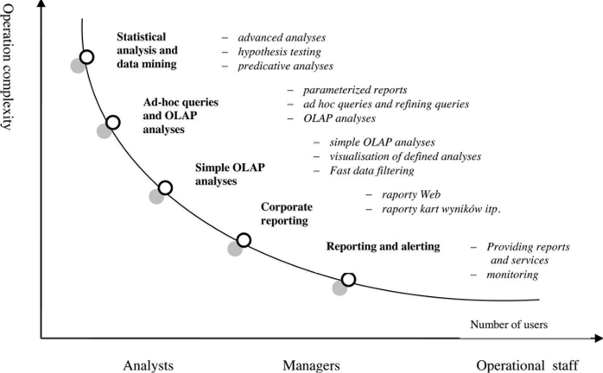
In this self-service age, BI platforms must provide functionality for analysts and executives, while allowing IT to integrate and protect corporate systems with centralised administration, performance management, fault tolerance and multilayer security.The five styles of BI are:
* Statistics and data mining.
* Ad hoc query and analysis.
* Cube analysis.
* Enterprise reporting.
* Report delivery and alerting.
Ad hoc query and analysis
Ad Hoc Query and Analysis - Full investigative query into all data, as well as automated slice and-dice OLAP analysis of the entire database - down to the transaction level of detail if necessary. Targeted at information explorers and power users.
Ad hoc query and analysis is where BI started. Only defined queries can be addressed, such as what the sales figures for the day are, or what a particular store has sold in any one day. This can be seen as 'primitive BI'.
Statistics and data mining.
Statistical Analysis and Data Mining - Full mathematical, financial, and statistical treatment of data for purposes of correlation analysis, trend analysis, financial analysis and projections. Targeted at the professional information analysts.

Statistics and data mining embrace the ability to use statistical treatment and data mining algorithms for predictive analysis. This is not a new development for BI tools. In the past, data mining tools were sold separately, but data mining is increasingly becoming one of the features of integrated BI tools. This is where the real value lies in BI. Companies can look at historical data and determine unknown trends.
Enterprise reporting.
enterprise Reporting - Broadly deployed pixel-perfect report formats for operational reporting and scorecards/dashboards targeted at information consumers and executives.

Enterprise reporting allows businesses to create and distribute 'pixel-perfect' reports, from the advanced requirements of power users to the 'at-a-glance' requirements of executives. Standard ERP systems perform this type of operational reporting. However, this style of BI has grown from merely operational to analytical, such as being able to produce sales figures for a particular month per region. Most BI tools can deliver such reports.
Cube analysis.
Cube Analysis - OLAP slice-and-dice analysis of limited data sets, targeted at managers and others who need a safe and simple environment for basic data exploration within a limited range of data.

Cube analysis can perform OLAP (online analytical processing) analysis on predefined subsets of data. Users experience increased speed and interactivity by working in such a manner. This is typically the kind of data required by analysts and analytical business managers. This is where users can start to get aggregated data, so analyses can be performed fairly quickly. Information is summarized by region by month, or product/brand by region, for example.
A cube always has aggregated data and can enable 'slicing and dicing'. One can also drill up, down or across different data sets, and down into detail in the data warehouse. That is the stage where the market finds itself. This type of OLAP capability is being implemented widely, delivering interactive reporting. It allows for train-of-thought analysis, such as where a region that is not performing well can be identified and the cause analyzed.
While the first company to implement cube analysis may have had a competitive advantage, this is no longer the case, as it has come to be widely implemented.
Report delivery and alerting.
Alerting and Report Delivery - Proactive report delivery and alerting to very large populations based on schedules or event triggers in the database. Targeted at very large user populations of information consumers, both internal and external to the enterprise.

Report delivery and alerting are the ability to disseminate reports and exception alerts on an enterprise scale through self-subscription or central administration. Reports can be received via any device, including e-mail, printer, text message, PDA, fax, pager and voice.
All of the other BI layers rely on a 'pull' scenario, where the user has to use the tool to perform the analysis, whereas this level acts in a 'push' manner. Its real value is its ability to trigger alerts when key performance indicators (KPIs) drop below certain predefined trigger levels. From the e-commerce side, it can be used to send marketing messages to a target audience. Combined with data mining tools, it identifies precisely the correct people to target with the appropriate message.
In the past, each vendor adopted a best-of-breed strategy, resulting in separate data mining, reporting, and OLAP tools. To simplify BI delivery capability, it makes more sense to use one platform and technology that combines all five styles, as they are all interrelated. Working with one technology results in lower TCO.
In addition, using five separate tools results in an integration nightmare. Each tool needs its own interface to data, whereas using one toolset eases integration issues. As there is only one user interface in a standard toolset, ease-of-use is guaranteed, meaning reduced end-user training.
Load balancing is also made easier, as a company only requires one administration tool to monitor the use of the data and balance the load to ensure users get the best performance out of the tool.
Security is improved, as users need only one log-on across all five different styles of BI, instead of five different log-ons to the separate tools.
These five styles merely comprise the toolset. Companies must start developing analytical tools that leverage these five styles. The BI market is maturing and there are analytical applications that can be used as templates for customer relationship management (CRM), supply chain management (SCM), corporate performance management (CPM), and balanced scorecard initiatives, as well as for analyzing customers in an e-commerce environment, and for fraud management.
In five years, organizations will be at the stage where they are using data mining in such a manner that they will reap the real rewards of BI and achieve the returns required by the company. True value will only be realized by appointing business analysts, with an understanding of the technology, as well as the ability to interpret the information into actionable result, to perform these duties.
Event-driven alerts in Business Intelligence (BI)
Event-Driven Alerts which is a warning or action that is activated when a predefined or unusual event occurs. For example, credit card companies have built extensive predictive analysis models to identify cases of possible fraud and automatically alert credit card customers for verification of transactions when unusual activity is noted (e.g. large purchase in an or foreign location when the customer does not have a history of such transactions). If a customer makes a large deposit, the bank may make an offer of a higher interest rate Certificate of Deposit (CD) or investment automatically.Such alerts are also used in generating promotions based on completion of other purchases. Of course, the alerts are also presented through BPM dashboards to appropriate managers responsible for key performance indicators when there are significant deviations from expected results.
Event-driven alerts in Business Intelligence (BI) refer to notifications or triggers that are generated based on specific events or conditions detected in the data. These alerts are designed to inform users or stakeholders about significant changes, anomalies, or predefined thresholds being met or exceeded.
Event-driven alerts in BI systems help organizations stay informed about critical business conditions, allowing them to proactively address issues or seize opportunities. Some examples of event-driven alerts in BI include:
Event-driven alerts play a crucial role in BI systems by providing timely and actionable information to users. They help in monitoring key performance indicators (KPIs) and critical metrics, allowing organizations to respond promptly to important events and make informed decisions.
Definition of Events and Triggers: Organizations identify the events or conditions that are relevant to their business operations and performance. These events can be predefined thresholds, deviations from expected values, changes in patterns, or specific data conditions. Triggers are set to detect when these events occur or conditions are met.
Monitoring and Data Analysis: BI systems continuously monitor the data and perform real-time or near real-time analysis to detect the specified events or conditions. This analysis can involve comparing data against predefined thresholds, statistical analysis, trend analysis, or machine learning algorithms.
Alert Generation: When an event or condition is detected, an alert is generated by the BI system. Alerts can take various forms, such as email notifications, SMS messages, pop-up messages, or dashboard notifications. The alerts typically contain information about the event, its significance, and any recommended actions.
Distribution and Delivery: The generated alerts are distributed to the relevant stakeholders, such as managers, analysts, or decision-makers. The alerts are delivered to the intended recipients through their preferred communication channels, ensuring that they receive the information in a timely manner.
Response and Action: Upon receiving an alert, stakeholders can analyze the situation, investigate the underlying causes, and take appropriate actions. These actions can include initiating further analysis, addressing the issue, or making informed decisions based on the alerted event.
Here's how event-driven alerts work in BI:
Define Events: Organizations identify the events or conditions they want to monitor in their BI system. These events can be based on various factors such as changes in data, performance metrics, anomalies, or specific business rules.
Set Thresholds or Rules: Thresholds or rules are established to determine when an event should trigger an alert. For example, a threshold can be set for a certain sales volume, customer churn rate, or inventory level. When the actual data surpasses or falls below these thresholds, an alert is triggered.
Continuous Monitoring: The BI system continuously monitors the relevant data sources or metrics in real-time or at regular intervals. It compares the current data against the predefined thresholds or rules.
Alert Generation: When an event or condition meets the specified criteria, the BI system generates an alert. Alerts can take different forms, such as email notifications, text messages, dashboard notifications, or pop-up messages.
Actionable Insights: Event-driven alerts provide timely and actionable insights to stakeholders. Decision-makers can promptly respond to critical events or take preventive measures when alerted about abnormal or significant changes in the data.

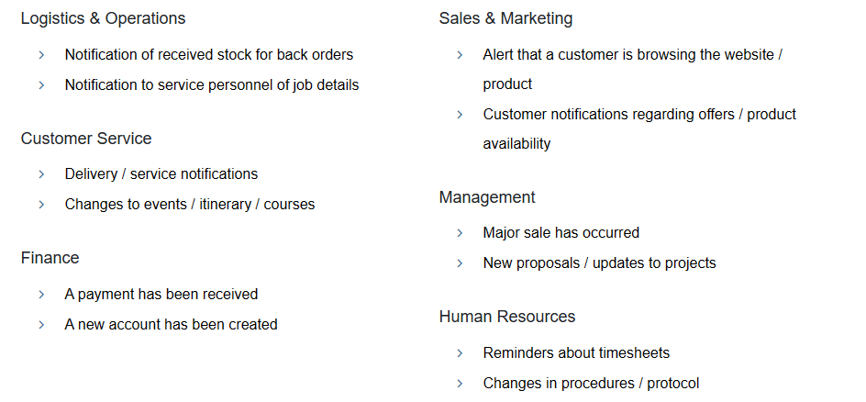
Examples of event-driven alerts in BI include:
Sales Alert: An alert triggered when sales revenue exceeds a predefined threshold or when a specific product's sales volume declines suddenly.
Performance Alert: An alert generated when a key performance metric, such as website response time or customer satisfaction score, falls outside the acceptable range.
Compliance Alert: An alert triggered when a regulatory or compliance requirement is violated, such as exceeding a certain level of unauthorized access attempts or data breaches.
Supply Chain Alert: An alert generated when inventory levels drop below a certain threshold or when a delay in the supply chain disrupts production.
Event-driven alerts in BI enable organizations to proactively monitor critical aspects of their business, identify anomalies or deviations, and take timely actions. They help stakeholders stay informed about significant events, allowing them to make informed decisions and address issues promptly to minimize potential risks and optimize performance.
A cyclic process of Intelligence Creation
In business intelligence (BI), the process of intelligence creation is often a cyclic or iterative process. It involves several key steps that are repeated to continuously generate intelligence and improve decision-making. Here's an overview of the cyclic process of intelligence creation in BI:
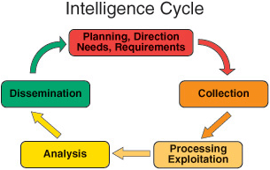

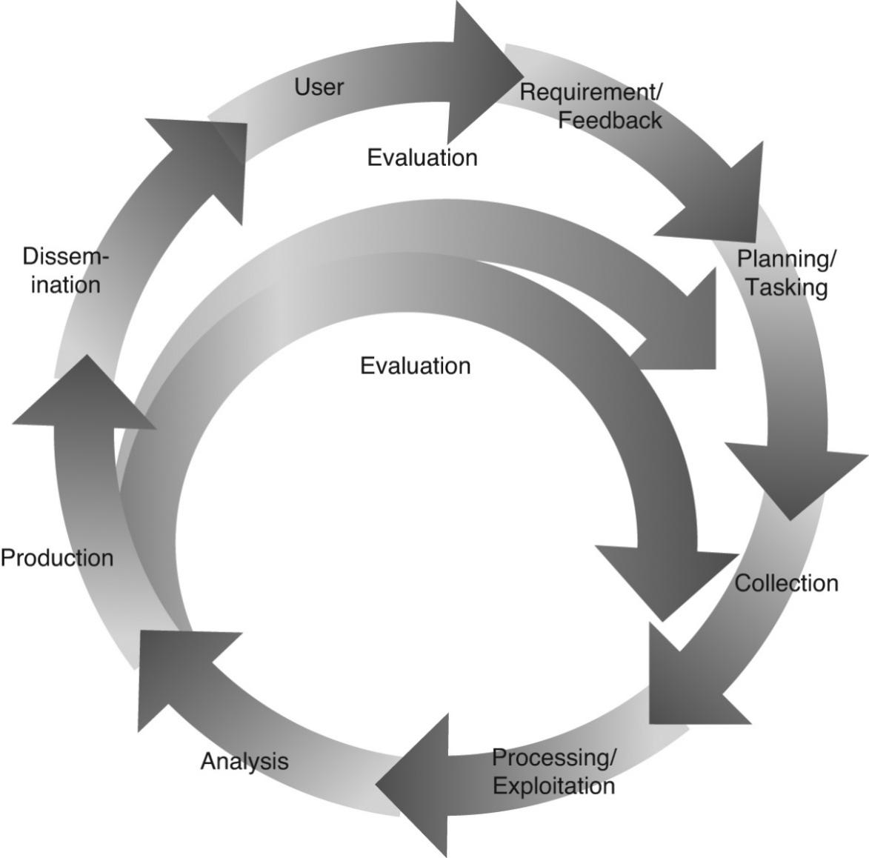

The cyclic process of intelligence creation refers to the iterative and continuous nature of developing intelligence within an organization or analytical framework. It involves a series of interconnected steps that collectively contribute to the generation of intelligence. While specific terminologies and approaches may vary, the general process typically involves the following stages:
Planning and Requirements: This initial phase involves understanding the organization's objectives, identifying intelligence requirements, and defining the scope and goals of the intelligence effort. It includes gathering inputs from stakeholders, determining key questions to be answered, and establishing the desired outcomes.
Collection and Gathering: In this stage, relevant data and information are collected from various sources, both internal and external to the organization. This can involve data mining, conducting research, leveraging open-source information, or gathering data through specific collection methods. The focus is on acquiring the necessary inputs to support the intelligence analysis.
Processing and Analysis: Once the data is collected, it undergoes processing and analysis to extract meaningful insights. This stage involves transforming raw data into a usable format, conducting data cleaning and normalization, applying analytical techniques, and utilizing tools and methodologies to derive intelligence from the collected information. This analysis may involve statistical analysis, data modeling, pattern recognition, or other analytical approaches.
Interpretation and Evaluation: The derived intelligence is interpreted and evaluated to assess its significance, reliability, and relevance. Analysts scrutinize the findings, identify patterns, evaluate potential biases or limitations, and determine the implications of the intelligence for the organization's objectives and decision-making processes. This stage involves critical thinking, subject matter expertise, and consideration of various perspectives.
Dissemination and Reporting: The intelligence is communicated to the relevant stakeholders in a clear and concise manner. This stage involves preparing reports, presentations, or briefings that effectively convey the insights and recommendations derived from the intelligence analysis. The information is disseminated to decision-makers, executives, or other users who can act upon the intelligence.
Feedback and Iteration: Feedback from stakeholders and users is collected and incorporated into the intelligence creation process. This stage involves reviewing the effectiveness of the intelligence, identifying areas for improvement, and making necessary adjustments to the planning, collection, analysis, or reporting processes. The feedback loop ensures that intelligence efforts continuously evolve and adapt to meet the changing needs of the organization.
The cyclic nature of intelligence creation acknowledges that intelligence is not a one-time effort but an ongoing process. It recognizes the need for continuous refinement, updating, and improvement based on new information, changing requirements, and evolving circumstances. The process is designed to ensure that intelligence remains relevant, accurate, and actionable for decision-making purposes.
The cyclic process of intelligence creation in BI enables organizations to continuously learn from data, gain insights, and make iterative improvements in decision-making. It emphasizes the importance of feedback, evaluation, and continuous improvement to enhance the effectiveness and value of business intelligence initiatives.
The Value of Business Intelligence
We might simply look at three different perspectives on information value versus use:
Functional perspective. From this point of view, processes focus on the tasks relating to a particular business function such as sales, marketing, finance, and such. Functional processes have a reliance on data within standard operating business activities to ‘‘run the business.’’ Transactional or operational applications can execute and successfully complete when they have the data specific for the immediate task. When the transaction or process is completed, the associated data may be archived or logged for future reference.
Cross-functional perspective. In reality, most businesses are run as a conglomeration of functional processes, and this is often reflected in more complex information technology applications (such as Enterprise Resource Planning, or ERP systems) to oversee the end-to-end processing of a sequence of operations.
Enterprise perspective. From an organizational perspective, observing the reported performance characteristics of cross-functional processes can inform enterprise architects and business analysts as to ways that the organization can change and improve the way things are done. By reviewing a collection of key performance indicators, the senior managers can seek to understand where bottlenecks or challenges are and determine approaches to alleviate their root causes. In this point of view, we might say that data is not just used to run the business, data is used to improve the business
Value Drivers and Information Use
Attempting to assign a monetary value to a single piece of information might be a challenge, but there are general value drivers within an organization that establish a foundation for generally assessing the corresponding information utility value.
Identifying organizational business objectives and then examining how (and what!) information is needed to meet those goals is a good first step, beginning with an enumeration of key business value driver vectors, as shown in Figure 2.1.
These four value drivers are:
Financial value, associated with improved profitability through a combination of increased revenues and decreased costs;
Productivity value, derived from increased throughput, improved process speeds, decreased manual intervention, and increased volumes;
Trust value, which relates to customer, market, employee, or supplier satisfaction; and
Risk value, associated with improved customer and market visibility, reduced capital risks, regulatory compliance, as well as reducing risks associated with leakage and fraud.
These value drivers are typically relevant at the enterprise level, yet they should permeate activities and performance measures across the entire organization. While the CEO might be interested in a rolled-up report of corporate profitability, the manager of each line of business (who is responsible for the profit and loss of that line) would be interested in a profitability report for his or her own area of the organization.
Alternatively, different functional managers would be informed by reports of their own specific drivers. These categories help the business analysts understand how performance measures relate up and down the management chain, and provide a framework for mapping specific business objectives (associated with anyone in the organization) to the delivery of actionable knowledge

- Horizontal Use Cases for Business Intelligence
Customer analysis
Following are different aspects of customer analytics that benefit the sales, marketing, and service organizations as they interact with the customers
Customer profiling.
This means that profiling the customers and identifying the key characteristics that differentiate the different de facto segments can guide the marketing and sales teams to better identify qualified prospects while reducing effort spent on nonproducing communities. To this end, customer analytics encompass the continuous refinement of individual customer profiles that incorporate demographic, psychographic, and behavioral data about each individual.
Personalization.
Personalization, which is the process of crafting a presentation to the customer based on that customer’s profile, is the modern-day counterpart to the old-fashioned salesperson who remembers everything about his or her individual ‘‘accounts.’
Collaborative filtering. We have all seen e-commerce web sites that suggest alternate or additional purchases based on other people’s preferences. In other words, the information on a web page may suggest that ‘‘people who have purchased product X also have purchased product Y.’’ These kinds of suggestions are the result of a process called collaborative filtering, which evaluates the similarity between the preferences of groups of customers
Customer satisfaction. One benefit of the customer profile is the ability to provide customer information to the customer satisfaction representatives. This can improve these representatives’ ability to deal with the customer and expedite problem resolution.
Customer lifetime value. The lifetime value of a customer is a measure of a customer’s profitability over the lifetime of the relationship, which incorporates the costs associated with managing that relationship and the revenues expected from that customer. Customer analytics incorporates metrics for measuring customer lifetime value
Customer loyalty. It is said that a company’s best new customers are its current customers. This means that a company’s best opportunities for new sales are with those customers that are already happy with that company’s products or services, so analyzing customer loyalty models as a way of flagging sentinel events leading to attrition can improve loyalty and extend customer lifetimes.
Revenue generation:
Targeted marketing.
Knowledge of a set of customer likes and dislikes can augment a marketing campaign to target small clusters of customers that share profiles. In fact, laser-style marketing is focused directly at individuals as a byproduct of customer analytics.
Cross-selling and up-selling.
Increasing same-customer sales is somewhat of an art, but involves advising customers of opportunities for getting better value from an increased order (up-selling) or by purchasing complementary items (crossselling). This involves analysis of transaction histories and customer predispositions, evaluating success patterns, and looking for common behaviors to find affinities between customer profiles and products and opportunities to make additional sales or sales of higher-end products.
Market development. This activity allows analysts to evaluate those demographic characteristics of understanding geographic dependencies to drive more efficient marketing programs targeted at geo-demographic profiles based on physical location. n Loyalty management. Determining when a customer is about to shutter their relationship provides a great opportunity to reestablish ties by providing discrete offers to stay. This type of analysis helps in reducing the loss of customers while providing profiles that can help in avoiding customers with a predisposition to defection.
HR and staff utilization
Salary and compensation modeling. This seeks to find the best ways to compensate staff in a way that encourages high productivity in the manner that is the most cost-effective for the organization.
Productivity and utilization. Here managers look to maximize staff throughput and productivity by better allocation of material resources over time.
Improved project delivery. This process analyzes overall staff performance to enable more efficient project planning to increase predictability for delivery.
Call center utilization and optimization. The value of analyzing call center utilization comes from improving call throughput while decreasing customer waiting time. This type of analysis can lead to increased customer satisfaction, improved support, and possibly increased sales.
Production effectiveness. This includes evaluating on-time performance, labor costs, production yield, and so on, all as factors of how staff members work. This information can also be integrated into an information repository and analyzed for value
Product and cost management
Price modeling, used to analyze the price point that will encourage the largest number of customers while maximizing profitability; n Product customization, where specific product features are provided for sale to specialized customer segments;
Distribution analysis, used to optimize product delivery and supply-chain logistics as a way to maintain consistent and predictable product availabi
Manufacturing efficiency, in which manufacturing processes are analyzed to find opportunities for streamlining;
Spend analysis, which incorporates processes to help evaluate sources of increased costs in relation to acquisition of goods, products, and services from different vendors and suppliers, and helps to organize views of products acquired by supplier price, and provides visibility into spending patterns to identify opportunities for negotiation for better vendor contract terms and performance;
Asset management and resource planning, where utilization, productivity, and asset lifecycle information can be integrated through business analytics to provide insight into short- and long-term resource planning, as well as exposing optimal ways to manage corporate assets to support the resource plan.
Operations
Defect analysis. While companies struggle to improve quality production, there may be specific factors that affect the number of defective items produced, such as time of day, the source of raw materials used, and even the individuals who staff a production line. These factors can be exposed through one component of business productivity analytics.
Capacity planning and optimization. Understanding resource utilization for all aspects of a physical plant (i.e., all aspects of the machinery, personnel, expected throughput, raw input requirements, warehousing, just-in-time production, etc.) through a BI analytics process can assist management in resource planning and staffing.
Site location. This is a process that organizations use to identify retail locations most suitable to the constituent customer profiles.
First-call resolution. Interaction patterns are mined to provide insight into ways to resolve customer complaints during the first call.
Finance and risk management;
Financial reporting. Stricter industry regulatory constraints may force companies to provide documentation about their financials, especially in a time when The Value of Business Intelligence 25 companies are failing due to misstated or inaccurately stated results. In addition, financial reporting analytics provide the means for high-level executives to take the pulse of the company and drill down on particular areas.
Risk management. Having greater accuracy or precision in tracking business processes and productivity allows a manager to make better decisions about how and when to allocate resources in a way that minimizes risk to the organization. In addition, risk analysis can be factored into business decisions regarding the kind of arrangements that are negotiated with partners and suppliers.
Fraud and abuse detection. Fraudulent (or abusive) behavior frequently is manifested in patterns. For example, there are many popular health insurance fraud schemes involving making claims with inflated charges or practitioners prescribing expensive medications or procedures that may not be necessary. Behavior analytics can be used to seek out patterns of suspicious behavior by provider, geographical region, agent, and so on.
Credit risk analysis. These are processes to assess individual or organizational credit risk, for underwriting insurance, and determining payment scenarios.
Supplier performance. Another aspect of spend analysis involves evaluating the performance of your company’s suppliers, reviewing variables such as consistency in pricing, speed of order delivery, credit ratings, and general compliance with contract terms. n Just-in-time. The concept of just-in-time product development revolves around the mitigation of inventory risk associated with commodity products with high price volatility.
Portfolio/demand/inventory analysis. These methods include assessment of product demand across temporal, geographic, and demographic variables to see how that can help in manufacturing, inventory, and supply chain optimization.
Supplier and vendor management. Many organizations are unable to identify who their vendors are or how many vendors are supplying products or services. Supply chain analytics allow a company’s management to track performance and reliability by supplier, evaluating and rating the quality of the products supplied, as well as help to optimize supplier relationships with respect to spending, procurement, and risk. n Shipping. There are different methods by which a company delivers its products to its customers, each with its own cost schedule. For example, it may be more expensive to ship products by air than by truck, but the products will arrive at the destination faster if shipped by air.
Inventory control. Maintaining an inventory of commodity products that exhibit volatile pricing and limited useful life creates a market risk if those products cannot be used before their obsolescence.
Distribution analysis. Imagine that your company has a large number of retail outlets, a smaller number of regional warehouses, and a very small number of factories. The optimal distribution model would arrange for the delivery of the exact number of products from each factory to its closest warehouses so that each warehouse could deliver the exact number of products to each of the retail stores
Sales channel analytics
Marketing. Both the ability to fine-tune a marketing program and the ability to determine marketing effectiveness can be derived through sales channel analytics.
Sales performance and pipeline. Data associated with the sales staff can be analyzed to identify variables that affect the efficiency of the sales cycle, such as individual sales staff member, region, industry, contact people, contact times, and contact frequency.
Behavior analysis
Purchasing trends. Although many product lifecycles can easily be predicted and charted, there are apparent nonlinear trends that elude predictability, the most notable cases being toy sales around winter holiday time.
Behavior analytics can be used to identify purchasing patterns that indicate a growing trend that can be used to adjust a company’s reaction to customer trends.
Web activity. In the world of e-commerce, the ability to draw and maintain customers to a web site and then encourage them to commit to purchasing 28 Business Intelligence products is not only critical to success, but also much more difficult than doing the same in a brick and mortar environment.
Customer attrition. Another serious problem for many businesses is customer attrition, when a company’s customers decide they no longer want to remain affiliated with that company.
Social network analysis. Sometimes it is important to identify relationships between specific entities within a system and to analyze their behavior as a group. For example, a component of criminal intelligence is finding collections of individuals whose individual behavior may be nondescript yet who act suspiciously as a group.
This kind of analytical processing is valuable to law enforcement, regulatory compliance (think of insider trading), marketing (consider viral marketing, which is a strategy that encourages individuals to pass your marketing message to all of their contacts), as well as sales optimization (by finding a contact path of people to find the right audience).
Sentiment analysis. Sentiment analysis combines text analytics, event analysis, and social network analysis to continuously monitor customer feedback from customer service notes, online postings, and via social media channels and be proactive in quickly addressing negative perceptions
- Vertical Use Cases for Business Intelligence
Health care.
For example, understanding why some practitioners are more successful at treating certain conditions can lead to improved quality of care. Improved diagnostic approaches can reduce the demand for high-cost diagnostic resources such as imaging machinery, and better treatments can reduce the duration of patient stays, freeing up beds, improving throughput, and enabling more efficient bed utilization.
Logistics/supply chain. Integrated analysis for transportation and logistics management sheds insight into evaluation of many aspects of an efficient supply chain. For example, BI is used to analyze usage patterns for particular products based on a series of geographic, demographic, and psychographic dimensions.
Telecommunications.
In an industry continually battling customer attrition, increasing a customer’s business commitment contributes to maintaining a long customer lifetime. For example, examining customer cell phone usage can help to identify each individual’s core network. If a customer calls a small number of residential land lines or personal mobile phones, that customer may be better served by a ‘‘friends and family’’ service plan that lowers the cost for the most frequently called numbers.
Retail.
The large volume of point of sales data makes it a ripe resource for analysis, and retail establishments are always looking for ways to optimize their product placement to increase sales while reducing overhead to increase their margins, especially when market baskets can be directly tied to individuals via affinity cards. Product placement is not limited to physical locations; massive web logs can be analyzed for customer behavior to help dynamically rearrange offer placement on a web site, as well as encourage product upselling based on abandoned cart analysis, through collaborative filtering, or based on the customer’s own preferences.
Financial services/insurance.
In both insurance and banking, identifying risks and managing exposure are critical to improved profitability. Banks providing a collection of financial services develop precise models associated with customer activities and profiles that identify additional risk variables. For example, analyzing large populations of credit card purchases in relation to mortgage failures may show increased default risk for individuals shopping at particular shopping malls or eating at certain types of fast food restaurants
Manufacturing. Plant performance analysis is critical to maintaining predictable and reliable productivity; tracking production line performance, machinery downtime, production quality, work in progress, safety incidents, and delivering measurements of operational performance indicators along the management escalation chain so that adverse events can be addressed within the proper context within a reasonable timeframe.
Hospitality. Hotel chains assess customer profiles and related travel patterns, and know that certain customers may be dividing their annual ‘‘night allocation’’ among the competitors. By analyzing customer travel preferences and preferred locations, the company may present incentive offers through the loyalty program to capture more of that customer’s night allocation.
Energy services. Increasing deployment of ‘‘smart meters’’ not only enables comparative reporting and analytics with customers to reduce demand while increasing efficiency through utility-managed powering of residential machinery (such as air conditioners), but understanding demand and usage patterns can drive acquisition and delivery strategies as well as help in identifying scenarios driving maintenance activity such as transient ‘‘flickers’’ indicative of imminent outages (dues to trees or animal damage).
Diagrams for understanting BI extra

